Wennikers summary: meh quality of references not very good, could do with better pics and is essentially reworded references for the most of it. But okay.

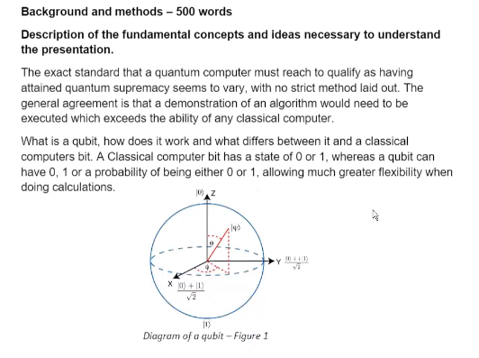

Usually multiple claims per paragraph, so there should be more references through paragraphs. Not just at the beginning and end. Site things in areas that it makes sense, he might check that.



Very short on the descriptions of the figures, inappropriate figures. Keep better sources for references. Not bad.

Explain Grover’s Algorithm, that is where the depth comes in. It reads as a little bit superficial.

Happy with the paper a bit of criticism for the structure though, the references are good and all recent, no references pointlessly referring to the same stuff.

Comp3002 Alternative Paradigms Alistair Drew - 10567887

Plan:

Quantum Supremacy, find out what this means, how quantum computing works in principle, what the problems with it are and what precisely Google has achieved.

2500 words – 3 most important references annotated.

Section 1 - Introduction (10%)

Section 2 - Background and Methods (20%)

* Describe the fundamental concepts and ideas necessary to understand section 3

Section 3 - Presentation of some specific main issues on the topic (50%)

Section 4 - Summary, discussion, and conclusions (10%)

* What are the main points to be learnt from the investigation and what are the problems that still need to be understood/worked out?

Section 5 – Background Literature (10%)

* What are the sources of information for your investigation?

Marks awarded for:

1. Organisation and clarity of written presentation
2. Use of figures and diagrams where helpful to illustrate key points.
3. The breadth and depth of your investigation.
4. The extent to which you can constructively bring together various aspects of the topic you are investigating to provide greater insight/understanding in the reader.
5. Ability to summarise the key ideas at the end of the report.
6. Quality of referencing and background literature.

DON'Ts:

* No bullet points.
* No table of contents
* Do not refer to "I" only describe the facts.
* No superficial information, just facts backed up by references with some explanations.
* No equations, instead talk about how the algorithm works and what it does.

Avoid rephrasing the references as this shows up on turntin and looks bad.

Make use of captions and pictures, tie the figures into the text, so people know why you show it.

Ensure the source of all references is scientific.

No need for meta information, titles of paragraphs should be contextual to report and not what they are called in the specs.

2-3 sentences per figure, Best if pictures that show something concrete about a system

When citing 3 authors in on reference, the first time you reference them in text use all three, then onwards only use the first author.

Order the scientific paper in the range from least specific broader stuff to more specificity.

General Intro to show the overview 🡪 Necessary Quantum Physics 🡪 Specific Details of the story

If use this diagram that shows the difference between qubits and classical bits, then if it makes sense in the context might want to talk about quantum circuits.